

**Batch: B-2 Roll No: 16010422234 Name: Chandana Galgali Date: 06/08/2024**

**Experiment No: 3**

**__________________________________________________________________________**

**Aim:** Implementation of basic commands in Linux and write a program to show file and process handling using system calls in Linux.

**__________________________________________________________________________**

**Resources needed:** Ubuntu 15.04 GNU.

**__________________________________________________________________________**

**Theory:**

In the realm of operating systems, Linux provides a rich set of system calls for managing files and processes. System calls serve as the fundamental interface between a process and the operating system, allowing user-space applications to request services such as file manipulation and process control from the kernel.

**File Management System Calls:**

open(): Open or create a file.

read(): Read data from a file.

write(): Write data to a file.

close(): Close an open file.

lseek(): Move the file pointer to a specified location.

stat(): Get file status.

fstat(): Get file status using a file descriptor.

chmod(): Change file permissions.

unlink(): Delete a file.

rename(): Rename a file.

**Process Management System Calls:**

fork(): Create a new process.

exec(): Replace the current process image with a new one.

wait(): Wait for a child process to change state.

exit(): Terminate a process.

getpid(): Get the process ID of the current process.

getppid(): Get the parent process ID.

kill(): Send a signal to a process.

sleep(): Suspend execution for an interval of time.

system(): Execute a shell command.

nice(): Change process priority.

**Pre lab/Prior concepts:**

Study the commands given.

**__________________________________________________________________________**

**Activity:**

1. Write a program to show file management and process management using system calls.

import os

import sys

import stat

import time

def file_management():

filename = "file.txt"

# 1. Open a file

fd = os.open(filename, os.O_RDWR | os.O_CREAT)

print(f"File '{filename}' opened with file descriptor {fd}")

# 2. Write to a file

os.write(fd, b"Hello, this is a test.\n")

print(f"Written to '{filename}'")

# 3. Read from a file

os.lseek(fd, 0, os.SEEK_SET)

data = os.read(fd, 100)

print(f"Read from '{filename}': {data.decode()}")

# 4. Get file status

file_stat = os.fstat(fd)

print(f"File status: {file_stat}")

# 5. Change file permissions

os.chmod(filename, stat.S_IRUSR | stat.S_IWUSR | stat.S_IRGRP | stat.S_IROTH)

print(f"Changed permissions of '{filename}'")

# 6. Move the file pointer

os.lseek(fd, 0, os.SEEK_SET)

# 7. Get file status using stat

file_stat = os.stat(filename)

print(f"File status using stat: {file_stat}")

# 8. Close the file

os.close(fd)

print(f"File '{filename}' closed")

# 9. Rename the file

os.rename(filename, "example_renamed.txt")

print(f"File renamed to 'example_renamed.txt'")

# 10. Delete the file

os.unlink("example_renamed.txt")

print("File 'example_renamed.txt' deleted")

def process_management():

# 1. Create a new process

pid = os.fork()

if pid == 0:

# Child process

print(f"Child process {os.getpid()} created")

# 2. Replace the process image

os.execlp("echo", "echo", "Hello from child process")

else:

# Parent process

print(f"Parent process {os.getpid()} waiting for child")

# 3. Wait for child process to change state

os.wait()

print("Parent process resumed")

# 4. Get process ID

pid = os.getpid()

print(f"Current process ID: {pid}")

# 5. Get parent process ID

ppid = os.getppid()

print(f"Parent process ID: {ppid}")

# 6. Change process priority

os.nice(10)

print(f"Process priority changed")

# 7. Send a signal to a process

pid = os.fork()

if pid == 0:

# Child process

print(f"Child process {os.getpid()} waiting for signal")

time.sleep(10)

else:

# Parent process

print(f"Parent process {os.getpid()} sending signal to child {pid}")

os.kill(pid, 9)

print("Signal sent to child process")

# 8. Sleep for a while

print("Parent process sleeping for 2 seconds")

time.sleep(2)

print("Parent process woke up")

# 9. Execute a shell command

os.system("ls -l")

# 10. Terminate the process

print("Terminating the process")

sys.exit(0)

if __name__ == "__main__":

print("File Management Activity:")

file_management()

print("\nProcess Management Activity:")

process_management()

**__________________________________________________________________________**

**Results: Perform the activity task and attach the snapshots here.**

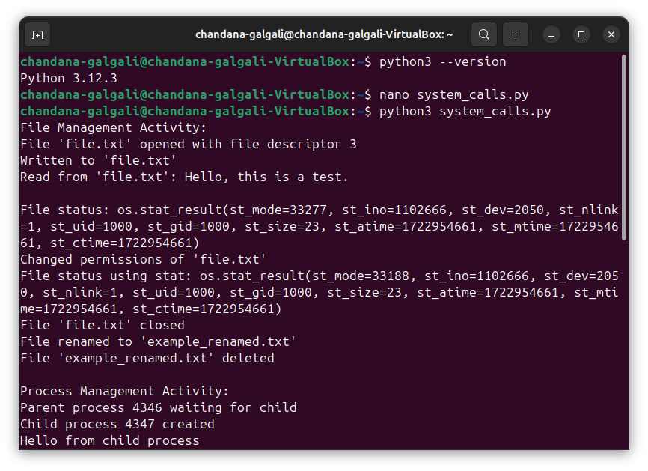

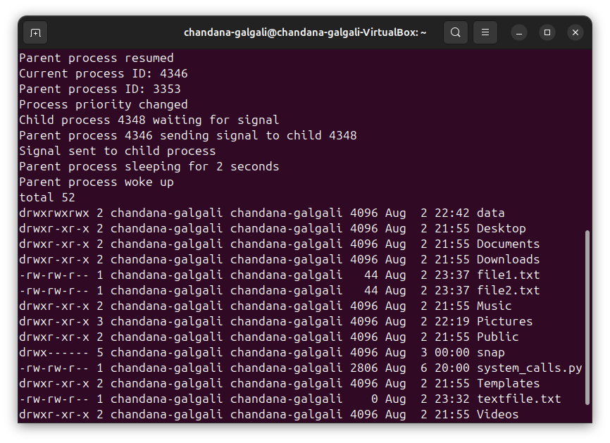

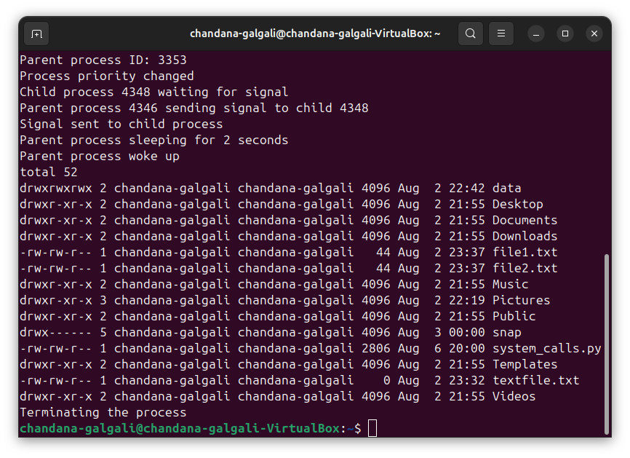

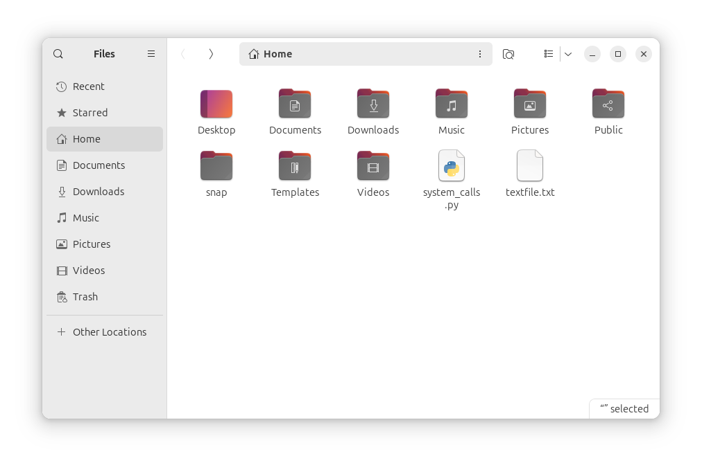

**__________________________________________________________________________**

**Outcomes:** CO1 -Understand basic structure of modern operating system

**__________________________________________________________________________**

**Conclusion:**

This experiment demonstrates the use of various Linux system calls for file and process management. Through the practical implementation of these system calls, we gain insight into how the operating system handles fundamental operations. Understanding these concepts is crucial for efficient system-level programming and contributes to a deeper understanding of operating systems.

**__________________________________________________________________________**

**Grade: AA/AB/BB/BC/CC/CD/DD**

**Signature of faculty in-charge with date**

**__________________________________________________________________________**

**References:**

**Books/ Journals/ Websites:**

1. Richard Blum and Christine Bresnahan, “Linux Command Line & Shell Scripting”, II Edition edition, Wiley, 2012.

**__________________________________________________________________________**